Databases – written exam
Computer Science in English, 2nd year, 2019

I. 1. A key is an unique attribute or set of attributes which can identify records in a table of a relational database.

2. A clustered index determines the physical order of data in a table. Each table can have only one clustered index.
For example, let's say we have a table called "Employees”. The table has a primary key column called "EmployeeID" and other columns such as "FirstName", "LastName", and "Salary".
If we create a clustered index on the "EmployeeID" column, the data rows in the "Employees" table will be physically sorted and stored on disk based on the EmployeeID values.

II. 1. a.
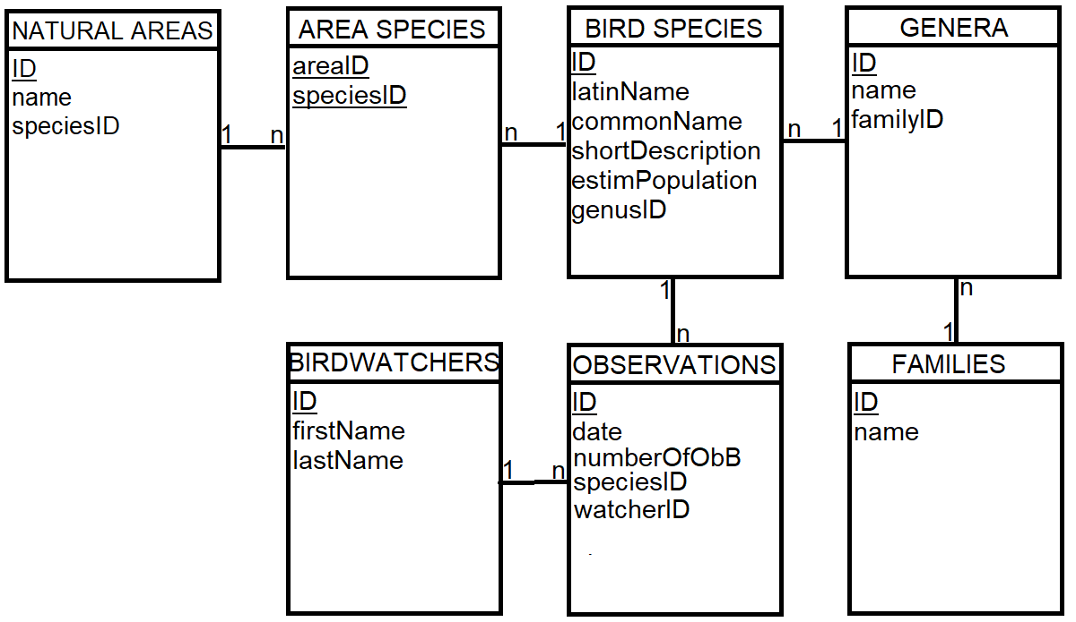
3NF is satisfied since all non-prime attributes are fully dependent on a key attribute.

b.
CREATE TABLE Families(
ID int primary key,
name varchar(30) not null
)

CREATE TABLE Genera(
ID int primary key,
name varchar(30),
familyID int references Families(ID)
)

2. a.
SELECT W.firstName, W.lastName, t1.totalNumOfObservations, t2.aqOb
FROM BirdWatchers W INNER JOIN (
SELECT O.ID, O.watcherID, COUNT(*) totalNumOfObservations
FROM Observations O
GROUP BY O.ID, O.watcherID
HAVING COUNT(*) > 10
) t1
ON t1.watcherID = W.ID
INNER JOIN (
SELECT O.ID, COUNT(*) aqOb
FROM Observations O INNER JOIN BirdSpecies B
ON B.ID = O.speciesID
INNER JOIN Genera G
ON G.ID = B.genusID
WHERE G.name = ‘Aquila’
GROUP BY O.ID
) t2
ON t2.ID = t1.ID

b. In T-SQL:
SELECT commonName, latinName, estimatedPopulation
FROM BirdSpecies NATURAL JOIN AreaSpecies
WHERE estimatedPopulation < 1000

In relational algebra:
π{BirdSpecies.commonName, BirdSpecies.latinName, BirdSpecies.estimatedPopulation}
(σ BirdSpecies.estimatedPopulation < 1000 (
BirdSpecies * AreaSpecies
)
)

III.
1. Correct answer/s: a, d
2. There are no null fields for M.
Correct answer/s: c
3. Correct answer/s: c
4. Correct answer/s: e
5. Correct answer/s: a
6. The query will run into an error, since P is not present in the GROUP BY clause.
Correct answer/s: a
7.
AB
A | B
A1 | B1
A1 | B1
A2 | B2
BC
B | C
B1 | C1
B1 | C2
B2 | C1

=> AB * BC
A | B | C
A1 | B1 | C1
A1 | B1 | C2
A2 | B2 | C1
AC
A | C
A1 | C1
A1 | C2
A2 | C1

=> AB * BC * AC = ABC
A | B | C
A1 | B1 | C1
A1 | B1 | C2
A2 | B2 | C1

Correct answer/s: a
8. Correct answer/s: c
9. Correct answer/s: c
10. Correct answer/s: c
11. It is in 3NF since all non-prime attributes are fully dependent on a key attribute/subset of a key. It is not in BCNF because of the functional dependency mentioned {A, C} -> {D}. All determinants must be candidate keys. {A, C} is not a candidate key.
Correct answer/s: a, b, c

12. Correct answer/s: c, d

IV.
E = 𝜎 A.AID = B.B1 AND B.BID=C.C2 AND C.C3=5
(
𝛱 {A.AID, A.A1, A.A2, B.BID, B.B1, C.C2, C.C3} (A×B×C)
)

E = 𝛱 {A.AID, A.A1, A.A2, B.BID, B.B1, C.C2, C.C3}
𝜎 A.AID = B.B1 AND B.BID=C.C2 AND C.C3=5 (A×B×C)

E = 𝛱 {A.AID, A.A1, A.A2, B.BID, B.B1, C.C2, C.C3}
𝜎 A.AID = B.B1 AND (B.BID=C.C2 AND C.C3=5) (A × (B×C))

E = 𝛱 {A.AID, A.A1, A.A2, B.BID, B.B1, C.C2, C.C3}
A ⨂ AID = B1 𝜎 B.BID=C.C2 AND C.C3=5 (B×C))

E = 𝛱 {A.AID, A.A1, A.A2, B.BID, B.B1, C.C2, C.C3}
A ⨂ AID = B1 B ⨂ BID=C2 𝜎 C.C3=5 C

E = (𝛱 {A.AID, A.A1, A.A2} A) ⨂ AID = B1 (𝛱 {B.BID, B.B1} B) ⨂ BID=C2 (𝛱 {C.C2, C.C3} 𝜎 C.C3=5 C)
